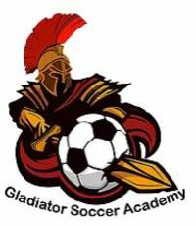
Accessibility and Inclusion Guide

Accessibility and Inclusion Guide policy ensures that Gladiator Soccer Academy (GSA) will be following the Canada Soccer Guide to Accessibility and Inclusiveness. GSA commits to its members the following:
• All GSA programs are equally accessible for all
• Each member being treated fairly and with respect
• The academy is responsible for setting standards and values to be applied throughout its
programs at every level.
Our commitment is to confront and eliminate discrimination by gender, sexual orientation,
marital status, race, nationality, ethnic origin, color, religion or belief, and ability or disability.
We strive to create and maintain equal opportunity for all members. This policy is fully supported by the directors, who are responsible for policy implementation and development. The academy will not discriminate or treat anyone less favorably on grounds of gender, sexual orientation, marital status, race, nationality, ethnic origin, color, religion or belief, and ability or disability.

Accessibility
Policy: As enacted by the Ontario government, AODA has been put in place to ensure accessibility for
Ontarians with disabilities in an attempt to make Ontario more accessible by 2025. Providing
Goods and Services to People with Disabilities GSA is committed to serving all customers including persons with disabilities/challenges.

Assistive Devices
- Assistive devices will be permitted and may be used by persons with disabilities when participating or benefitting from the goods and services pertaining to GSA activities .
- Assistive devices may not be permitted if the use of the device poses risk to the health and safety of the person using the device or to others using the goods and services of the organization.
All Facilities are accessible to:
o Wheelchair ramps
o Wheelchair accessible public washrooms and change rooms
o Elevator access

- Support persons for people with disabilities are allowed to enter

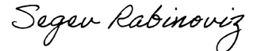
Sincerely,
Segev Rabinoviz
Owner, Gladiator Soccer Academy

