Rule of Two

When a Gladiator Soccer Academy (GSA) Volunteer Coach, Assistant Coach or Manager is in a potentially vulnerable situation with any GSA player (ie. locker room or meeting room), another GSA Coach, Volunteer Coach, Assistant Coach, Manager or the parent/guardian of the player(s) must be present.

In any one-on-one situation with any GSA player, there must be a Coach, Assistant Coach or Manager of the same gender present, or the player’s parent/guardian must be present.
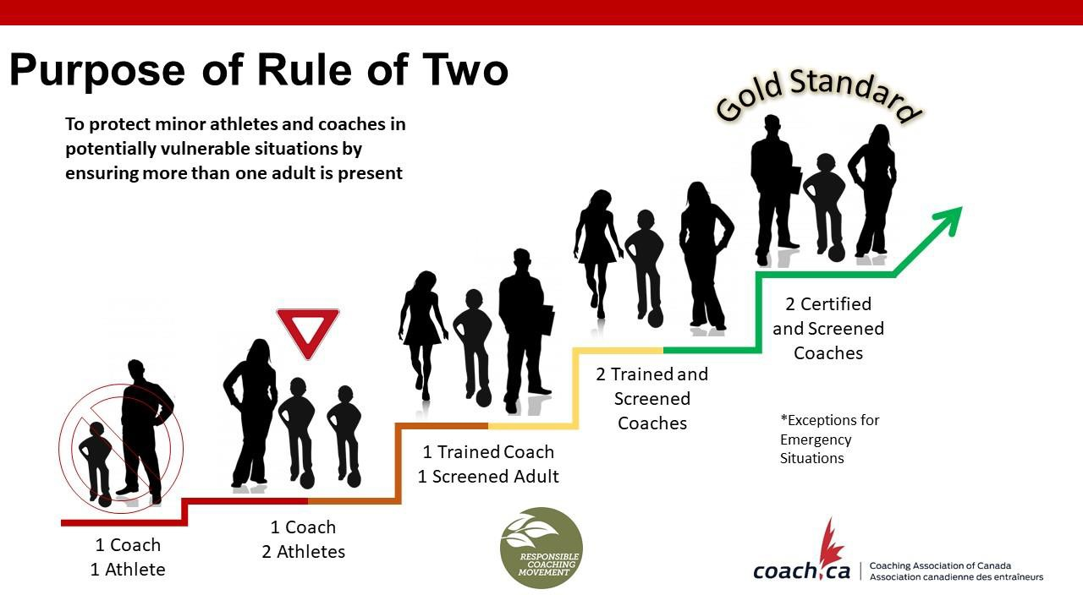

The goal of the Rule of Two is to ensure all interactions and communications are open, observable, and justifiable. Its purpose is to protect participants (especially minors) and
coaches
in potentially vulnerable situations by ensuring more than one adult is present. There may be exceptions in emergency situations.

Current GSA practices for implementing the Rule of Two

- Ensure a coach is never alone and out of sight with a participant without another screened coach or screened adult (parent/guardian or volunteer) present.
- Allow the training environment to be open to observation.
- Ensure a participant rides in a coach's vehicle with another adult present.
- Consider the gender of the participant(s) when selecting the screened coaches and volunteers present.
- Eliminate one-to-one electronic messaging. Ensure that all communications are sent to the group and/or include parents/guardians.

Further recommendations for Rule of Two in a Virtual Setting:
- The Rule of Two should continue to apply to all minor athletes in the virtual environment during the COVID-19 pandemic (for those athletes under age 16, a parent or guardian should be present during the session where possible)
- We recommend applying the Rule of Two to non-minor athletes, as well, in the current circumstances
- For every session, the Rule of Two would require two adult coaches be present, or one coach and one adult (parent, guardian, volunteer, club administrator) one-on-one sessions should be prohibited
- A clear statement of professional standards expected of the coach during calls should be
communicated (ie. sessions are not social engagements, and should be focused on training)
- Parents/guardians should be fully informed beforehand about the activities undertaken
during the sessions, as well as the process of the virtual session;
- Parents/guardians should be required to consent to virtual sessions prior to each session, if irregularly scheduled, or prior to the first session if there is a series of regularly scheduled sessions;
- Communication during each session should be in an open and observable environment (i.e., avoid bedrooms) in the athlete’s home (athlete’s parents’/guardians’ home), and the coach must initiate the session from an appropriate location (i.e., avoid bedrooms or “overly personal”/unprofessional settings);
- It is recommended to record sessions where that capacity exists;
- Prohibit one-on-one texting, emailing or online contact between coach and athlete – any texting, emailing or online contact should be limited to group text/email that includes at least two adults (two coaches or one coach and one adult (parent, guardian, volunteer, club administrator), and limited to coaching (non-social) matters, and parents of minor athletes should be provided the opportunity to receive these texts/emails;
- Social media contact by coach to athlete should be prohibited (including the sharing of memes, non-training video, etc.);
- Encourage parents/guardians to debrief with U-16 athletes about virtual training on a
weekly basis.
In addition, care should also be taken to ensure that appropriate security settings have been set for virtual, videoconferencing arrangements, including password protected videoconference invitations.

Additional Resources:

- NCCP Code of Ethics

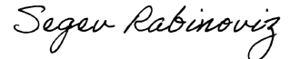
Sincerely,
Segev Rabinoviz
Owner, Gladiator Soccer Academy

